**Project Deliverable One**



**Prepared by**

**Group Number: Team 16**

**Lucien GEORGE - 260571775**

**Ossama AHMED - 260549558**

**Zeyad SALEH - 260556530**

**Aliaa MOHARRAM - 260572705**

**Instructor: Bettina Kemme**

**Course Number: COMP 421**

**Course Name: Database Systems**

Table of Contents

1 Scope 3

2 Database Requirement Analysis 4

3 E/R Model 6

4 E/R Model Translation into Relations 7

# Scope

The project will be to build an ecommerce platform where any student can sell their clothes, textbooks, furniture..etc to other students on campus.  This already happens on a Facebook group called Free & For sale. The platform should allow the seller to set their minimum price and the potential buyers to bid on the items. A seller will be allowed to see each bid, seen from an anonymous buyer but the rating of the buyer will be visible, and approve to complete the transaction of one bid only. Once a transaction takes place, the item will be removed from the items on sale, and the buyer and the seller will have to communicate through email to set up a time for delivery or pickup. This platform main goal is to facilitate the trading of second hand items that the student doesn’t use anymore. It is easy for students to meet each other since usually most students live around the campus.

# Database Requirement Analysis

* A user creates an account to access the platform, by signing up and entering information such as first name, last name, email, date of birth, university, home address and gender.
* A user can buy or sell items by navigating through the platform after signing in.
* A seller can post one or more items for sale.
* A user can access and view the items on sale by choosing a certain category from the available ones.
* A buyer can choose to bid on one or more items in different categories.
* An item belongs to a certain category and contains information relevant to that category.
* The available categories are: Clothing, Books, Cars, Furniture, Appliances, Music Instruments, Event Tickets, Electronics, Sports, Grooming, Others.
* Each item has shipment information (i.e. pickup or delivery) and a description that cannot exceed 300 words.
* ***The following are the available categories and their required information***
  + **Clothing:** size, condition, brand, colour, description.
  + **Books:** edition, author, title, literature type (philosophy, physics, maths, etc.), description.
  + **Cars:** model, year, car type, exterior colour, interior colour, description.
  + **Furniture:** material (wood, metal, plastic, cotton, etc), condition, colour, dimensions, description.
  + **Appliances:** model, brand, type, release date, dimensions, description.
  + **Music Instruments:** Condition, type of instrument, year, description.
  + **Tickets:** date, time, type of ticket (i.e. concert, theatre, etc.), description.
  + **Sports:** brand, kind, condition, description.
  + **Grooming:** kind, brand, description.
  + **Others:** description**.**
* One Auction is held for one item for sale only.
* The active users participating in the auction are kept anonymous until a transaction is approved.
* When a transaction is approved the emails of both parties will be exchanged to deliver the item.
* A seller can start an auction by putting an item for sale. Several buyers can participate in an auction
* An auction has a maximum active duration of 6 months. If the item is unsold by that period of time, the auction is automatically cancelled.
* An auction has a start time, an end time, an initial bid price and every buyer’s bid.
* An auction ends either by a transaction or by exceeding the duration limit or if the seller decides to remove the item before a transaction happens.
* A transaction takes place when the seller approves exactly one buyer’s bid. (Not necessarily the highest bid)
* An item should have a status of available for bidding, inactive or sold.
* A bidder can re-bid several times, the newest bid cancels the previous one.
* The buyer’s cart is a collection of auctions that a buyer is participating in.
* The seller’s cart is a collection of auctions that a seller is selling.
* A transaction connects an item’s seller to its buyer. It also includes the approved bid price and the transaction date and time.
* After a successful transaction, the sold item changes status from available to sold
* The two users involved in a certain transaction can write a review concerning the other user, and provide them a rating on a scale from 1 to 5. These reviews will be available for any future users.

# E/R Model

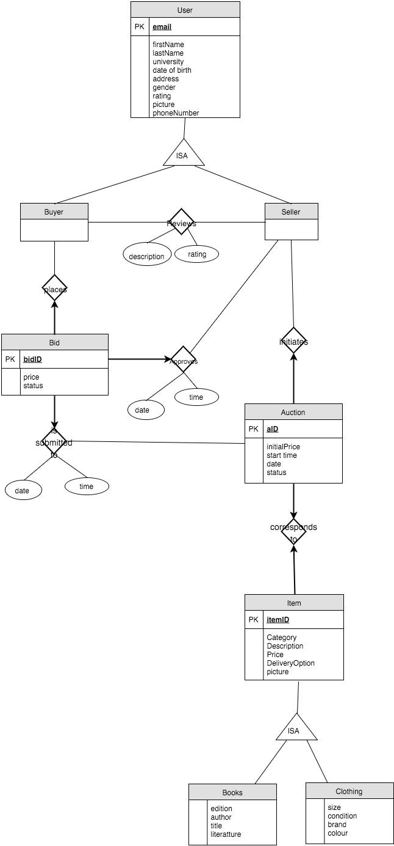

# E/R Model Translation into Relations

User(email, fname, lname, DoB, gender, university, address, rating, picture)

Auction(aID, status, initialPrice, startTime, date, *email*, *itemID*, highestBid)

Bid(bidID, bPrice, time, date, status, *email*, *aID*)

Item(itemID, description, name, deliveryOption, category, picture)

Clothing(size, condition, brand, colour, itemID)

Books(edition, author, title, literature type , itemID)

Reviews(rating, description, *revieweeEmail*, *reviewerEmail*)

Approves(date, time, *buyerEmail*, *sellerEmail, bidID*)